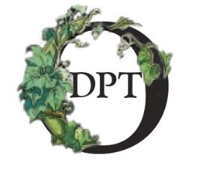
Save The Stones
Dunollie Castle Phase III Consolidation

Why not join us in taking our castle to a new level by saving the stones!
​
All you need to do is tell us how much you would like to donate and help us in rebuilding this fascinating ancient ruin.
​
Stones Sizes:
​
£5 Donation: Save a small stone
£20 Donation: Save a medium stone
£50 Donation: Save a large stone
​
Each stone is numbered, and we will allocate you a stone. Please let us know if you are happy for us to email you with the number of your stone.

All you need to do is complete the form attached. Hand your completed form into our reception booth along with your donation.
​
Alternatively, you can send your form with your donation to:
​
Castle Phase III Fundraising
North Wing
Dunollie House
Oban
PA34 5TT
​
If you are a UK Tax payer, remember to let us know if you would like to add Gift Aid to your donation.

You can follow the progress of our save the stones campaign on our website: www.dunollie.org
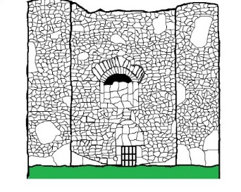

Save The Stones
Dunollie Castle Phase III Consolidation

Title
First Name
Surname
Address

Postcode
Email
Please include the number of stones you would like to save beside the donation | £5 (Small Stone) £20 (Medium) £50 (Large)
Total Donation | £
Are you happy for us to email you with the number of your stone? | Yes No
Would you like to be acknowledged in our donners list or remain anonymous? | Yes, acknowledge me I’d like to be anonymous
I would like to add Gift Aid*  (*Eligible for UK taxpayers only) | Yes No  (If Yes, please remember to include all your details above)

Would you like to be added to our mailing list? We send out Dunollie Newsletters once a month: Yes No
We will not pass any of your information onto third parties. All information kept will be stored securely in compliance with the General Data Protection Regulations 2018.

If you would like any more information about Gift Aid, visit the HMRC’s Gift Aid Page.

