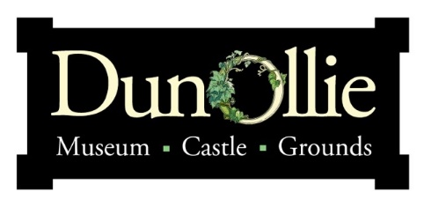
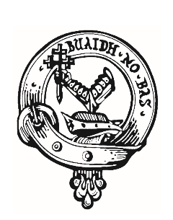
Clan MacDougall

Dunollie is very proud to be the Seat of the Clan MacDougall.
We are working to unite MacDougall’s worldwide to share their heritage and receive exclusive Clan benefits.

If you would like to be part of the worldwide Clan MacDougall Database, please include your details below.
A quarterly newsletter will be sent out with Clan news.

Name:
Address:
Country:
Email:
Phone Number:
Would you like to be included in the monthly Dunollie Newsletter? YES NO
Signed:

